Supplementary Table 1, Figure 1, Figure 2 for bone marrow features in patients with acute myeloid leukemia treated with novel targeted isocitrate dehydrogenase 1/2 inhibitors
Patient | Date | Diagnosis | Cellularity (%) | Blast (%) | Flow Cytometry Results | Cytogenetics | FISH | Molecular (VAF)
1 | Diagnostic Bone Marrow Biopsy | AML, NOS | 50 | 60 | Blasts positive for CD34 partial, CD13, CD33, HLA-DR, CD38, CD11c, CD117, CD64 dim; blasts negative for cCD3, CD56, cCD79a, TdT, MPO | 47,XX,+8[17]/46,XX[3] | ND | DNMT3A, IDH2, BCOR
 | Day 22 |  | 40 | 50 | Blasts positive for CD34, CD13, CD33, HLA-DR, CD38, CD11c, CD117, CD64 dim | 47,XX,+8[1]/46,XX[19] | ND | ND
 | Day 165 |  | 30-40 | <5 | Proportionally increased basophils (4.4% of leukocytes) with mild immunophenotypic alterations identified on myeloid blasts (3.8% of leukocytes) with mildly increased CD4, CD33, and CD123, and mildly decreased expression of HLA-DR, and CD7 expressed on a minor subset; monocytes proportionally increased 17.3% with myeloid and monocytic left shift | 46,XX[20] | Negative for +8 | ND
 | Day 188 |  | 10-20 | <5 | Proportionally increased basophils with mild immunophenotypic alterations identified on myeloid blasts (2.3%) including mildly increased CD33 and CD123, and slightly decreased HLA-DR, and CD7 on a subset. | 46,XX[20] | ND | Negative for IDH2 mutation
 | Day 312 |  | 20-40 | <5 | No abnormal myeloid blast population identified | ND | Negative for +8 | Negative for IDH2 mutation
2 | Diagnostic Bone Marrow Biopsy (outside facility) | AML-MRC | 40 | 20 | Blasts positive for CD13, CD33, CD34, CD38, CD45 dim, CD117, HLA-DR | 46,XY[20] | Positive for 20q- [6/200] | ND
 | Diagnostic Bone Marrow Biopsy (onsite) |  | 40 | 20 | Blasts positive for CD13 dim, CD33 dim partial, CD34, CD36 partial, CD38, CD117, HLA-DR, and MPO partial; blasts negative for CD14, CD56, TdT, and lymphoid markers | ND | Negative for 20q- | IDH2 R140 (42%), STAG2 (84%)
 | Day 14 |  | <10 | 10-15 | Abnormal myeloid blasts with CD15 (small subset), CD33 decreased, CD38 decreased to absent, CD45 decreased, CD71 decreased, CD117 decreased, CD123 decreased, normal CD13, CD34, HLA-DR; negative for CD4, CD5, CD7, CD14, CD16, CD19, CD56, CD64 | 46,XY[8] | ND | ND
 | Day 21 |  | <5 | 20 | Blasts positive for CD45 dim, CD13, CD33 dim partial, CD34, CD36, CD38, CD117 partial; blasts negative for CD14, MPO, TdT, lymphoid | ND | ND | ND
 | Day 54 |  | <10-30 | <5 | 2.7% abnormal myeloid blasts with CD15 (small subset), CD33 decreased, CD34 decreased, CD38 absent, CD45 decreased, CD117 decreased, HLA-DR slightly decreased, with normal CD13, CD71, CD123; negative for CD4, CD5, CD7, CD14, CD16, CD19, CD56, CD64 | 46,XY[20] | Negative for 20q- | ND
 | Day 93 |  | 30 | <5 | 6.1% abnormal myeloid blasts with CD13 mildly decreased, CD15 (small subset), CD33 slightly decreased, CD34 variable slightly decreased, CD38 variably decreased, CD45 decreased, CD117 decreased, CD123 variable, with normal CD13, CD71, HLA-DR; small subset (0.3%) of CD34-positive blasts expresses cCD3, CD5 dim, CD7 bright; negative for CD4, CD14, CD16, CD19, CD56, CD64 | ND | ND | ND
 | Day 181 |  | 10-40 | <5 | 1.1% abnormal myeloid blasts with CD13 decreased, CD15 (small subset), CD33 variable decreased, CD34 decreased, CD38 large subset absent, CD45 decreased, CD71 large subset absent, CD117 decreased, CD123 variably decreased, with normal HLA-DR; small subset 0.07% of CD34-positive blasts expresses bright CD7, intermediate CD5; negative for CD4, CD14, CD16, CD19, CD56, CD64 | 46,XY[20] | ND | ND
 | Day 306 |  | 20-30 | <5 | 0.46% abnormal myeloid blasts with CD15 (small subset), CD33 slightly decreased, CD34 decreased, CD38 low to absent, CD45 decreased, CD71 large subset absent, CD117 decreased, CD123 decreased, with normal CD13, HLA-DR; small subset 0.13% of CD34-positive blasts expresses bright CD7 and intermediate CD5; negative for CD4, CD14, CD16, CD19, CD56, CD64 | 46,XY[20] | ND | ND
3 | Diagnostic Bone Marrow Biopsy | AML-MRC | 95 | 32 | Blasts positive for CD4 dim, CD13 dim, CD34, CD117, HLA-DR, and MPO dim; blasts negative for CD11b, CD11c, CD14, CD15, CD16, CD36, CD33, CD64, TdT, and lymphoid markers | 43~47,X,-X,t(1;15)(p36.1;q15),der(3;12)  (3pter->3p21::12p13->12q24.3::3p21->3qter),t(3;6)(p13;p25),del(5)(q31q35),  add(6)(p21.1),+8,+8,add(8)(p11.2),del(8)  (p21),i(8)(q10)x1~2,del(12)(p11.2) | Positive for -17 [122/200] and 8q+ [144/200] | IDH2 R140 (45%), TP53 (57%), BCOR (uncertain 51%), DNMT3A (Uncertain 46%)
 | Day 98 |  | 60 | 10-15 | Abnormal myeloid blasts with CD4 low, CD13 decreased, CD33 decreased on major subset, CD34 decreased, CD117 increased on subset, HLA-DR absent on minor subset, with normal CD38, CD45, CD71, CD123; negative CD5, CD7, CD14, CD15, CD16, CD19, CD56, CD64 | 44~46,XX,del(5)(q15q33),+8,add(8)(p11.2),del(8)(p21),i(8)(q10),-16,-17,+mar[cp5]/46,XX[2] | ND | ND
 | Day 154 |  | 70 | <5 | CD117+ progenitor population shows erythroid differentiation | 44~46,XX,der(3;12)(3pter->3p21::12p13->12q24.3::3p21->3qter),del(5)(q15q33),-7,+8,add(8)(p11.2), | ND | ND
 | Day 219 |  | 90 | 90 | Blasts positive for CD45 dim, CD4 dim, CD13 dim, CD34, CD36 subset, CD117, HLA-DR, MPO (dim minor subset); Negative CD11b, CD14, CD15, CD16, CD33, CD64, TdT | 43~46,XX,der(3;12)(3pter->3p21::12p13->12q24.3::3p21->3qter),del(5)(q15q33),+8,i(8)(q10)x1~2,add(11)(p15),-16,-17,-22,+mar[cp20]/46,XX[1] | ND | IDH2 R140 (43%), TP53 (69%), DNMT3A (uncertain, 46%), BCOR (uncertain 53%)
 | Day 250 |  | 70-80 | 30-40 | Immature myelomonocytic cells positive for CD45 dim to moderate, CD4 dim, CD13 dim, HLA-DR; Negative CD14, CD34, CD117 | ND | ND | Positive for IDH2 R140 and TP53 mutations
4 | Diagnostic Bone Marrow Biopsy |  | >95 | 23 | Blasts positive for CD34, CD33 dim, CD13 dim, CD117, HLA-DR, CD7 dim; blasts negative CD3, CD4, CD8, CD5, CD10, CD20, CD14, sIg | 47,XY,+8[20] | ND | IDH2 R140 (44%), SRSF2 (44%), STAG2 (60%), ETV6 (uncertain 46%)
 | Day 14 |  | 20 | 30-40 | Blasts positive for CD34, CD13, CD33 dim, CD117, CD7 partial, HLA-DR, MPO partial | ND | ND | ND
 | Day 48 |  | <5-70 | <5 | Negative | 47,XY,+8,del(12)(p11.2)[2]/46,XY[18] | ND | ND
 | Day 104 |  | 50 | <5 | Negative | 46,XY[20] | ND | ND
 | Day 284 |  | 30 | <5 | 0.2% abnormal myeloid blasts positive for CD4, CD34 increased, CD117 decreased to absent, CD123 increased, HLA-DR decreased with normal CD13, CD33, CD34, CD38, CD45, CD71; negative CD5, CD7, CD14, CD15, CD16, CD19, CD56, CD64 | 46,XY[20] | Negative for +8 | ND
 | Day 340 |  | 40 | 5 | 2.3% abnormal myeloid blasts positive for CD4, CD13 increased, CD34 increased, CD71 slightly increased, CD117 subset decreased to absent, CD123 increased, with normal CD33, CD38, CD45, HLA-DR, and CD15 (may be low level); negative CD5, CD7, CD14, CD16, CD19, CD56, CD64 | ND | ND | ND
 | Day 404 |  | <10-40 | 20-30 | Blasts positive for CD4 dim, CD7 dim partial, CD13, CD33 dim, CD34, CD117, and HLA-DR; blasts negative CD56, B and T | ND | ND | ND
5 | Diagnostic Bone Marrow Biopsy | AML-MRC | 80 | 92 | Blasts positive for CD4 dim, CD13 dim, CD33 partial dim, CD34, CD117, HLA-DR, and MPO; blasts negative CD3, CD10, CD14, CD19, sIg, TdT, B and T | 43~46,XX,add(2)(q11.2),der(3;17)(p10;q10),-5,-8,+11,add(11)(q23),der(11;15)(q10;q10),-13,-17,-17, | Negative | IDH1 R132 (49%), TP53 (94%), DNMT3A (47%, 48%)
 | Day 14 |  | 80 | 98 | ND | 41~45,XX,-X,add(2)(q11.2),t(3;17)(p10;q10),add(4)(p16),-5,del(6)(p23),+11,der(11)add(11)(p11.2)add(11)(q21),der(11;15)(q10;p10),add(12)(p11.2),add(12)(q12),-13,-17,-17, add(19)(p13.3), | ND | ND
 | Day 127 |  | 80 | <5 | 0.8% abnormal myeloid blasts with increased CD38, CD71, and high level CD117 and HLA-DR; negative CD13, CD15, CD33, CD64, CD123 | 43~45,XX,add(2)(q11.2),del(3)(q12),-5,del(6)(p23),+11,der(11)add(11)(p11.2)add(11)(q21),der(11;15)(q10;q10),-12,der(12;17)(q10;q10),-13,-17,-17,add(19)(p13.3),add(21)(p11.1),-22,+1~3mar[cp20] | ND | ND
 | Day 171 |  | 10 | <5 | ND | ND | ND | ND

Table 1. A summary of the findings for each of the patients: dates, diagnosis, cellularity levels, blast levels, flow cytometry results, cytogenetic results, FISH results, and variant allele frequencies (VAFs).AML, acute myeloid leukemia; AML, NOS, acute myeloid leukemia, not otherwise specified; AML-MRC, acute myeloid leukemia with myelodysplasia-related changes; ND, not done.

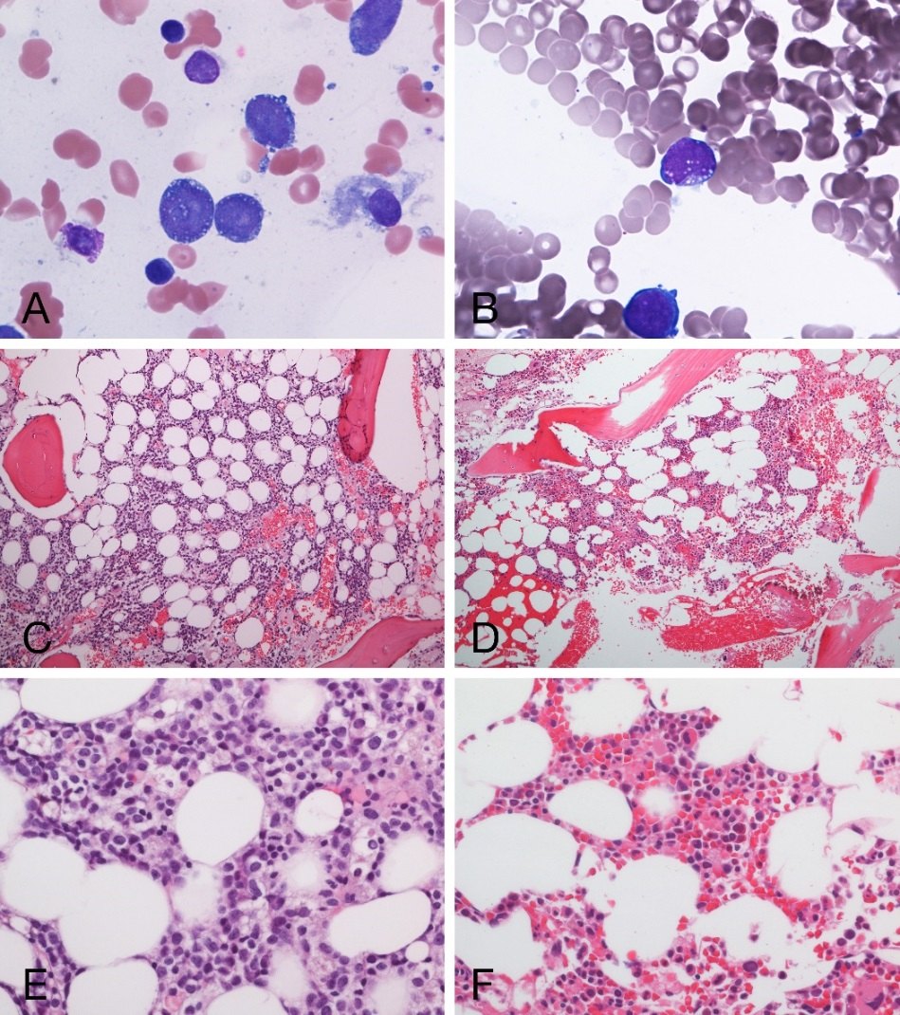
Figure 1.Composite of bone marrow biopsies from patient 1. (A, C, E) Bone marrow biopsy at diagnosis; (A) Aspirate showing blasts with cytoplasmic vacuoles, Wright-giemsa stain, 100X objective; (C) Trephine biopsy showing a normocellular bone marrow, hematoxylin and eosin (H&E)-stained section, 10X objective; (E) Trephine biopsy showing sheets of blasts, H&E-stained section, 40X objective. (B, D, F) Bone marrow biopsy after enasidenib; (B) Aspirate showing a rare immature mononuclearcell with cytoplasmic vacuoles, suspicious for a blast; (D) Trephine biopsy showing a hypo- to normocellular bone marrow, H&E-stained section, 10X objective; (F) Trephine biopsy showing trilineage hematopoiesis, H&E-stained section, 40X objective.
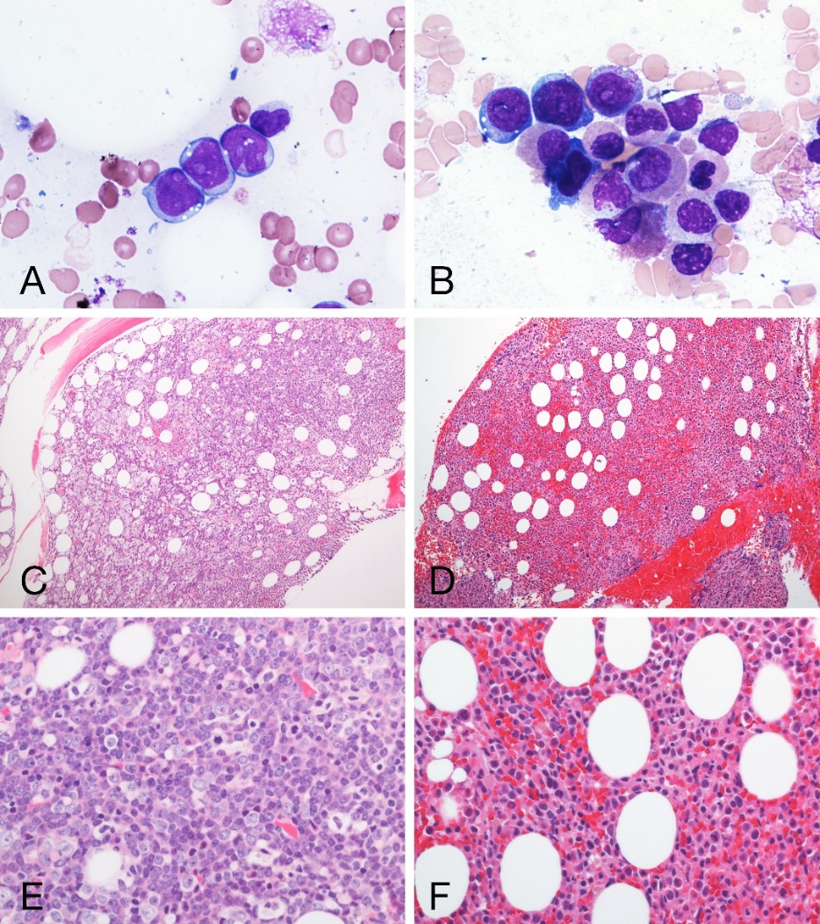
Figure 2. BComposite of bone marrow biopsies from patient 5. (A, C, E) Bone marrow biopsy at diagnosis; (A) Aspirate showing blasts with cytoplasmic vacuoles, Wright-giemsa stain, 100X objective; (C) Trephine biopsy showing a hypercellular bone marrow, hematoxylin and eosin (H&E)-stained section, 10X objective; (E) Trephine biopsy showing sheets of blasts, H&E-stained section, 40X objective. (B, D, F) Bone marrow biopsy after ivosidenib; (B) Aspirate showing left-shifted erythroid precursors with occasional cytoplasmic vacuoles and left-shifted granulocytes; (D) Trephine biopsy showing a hypercellular bone marrow, H&E-stained section, 10X objective; (F) Trephine biopsy showing trilineage hematopoiesis with left-shifted erythroid and granulocytic maturation and small megakaryocytes, H&E-stained section, 40X objective.

