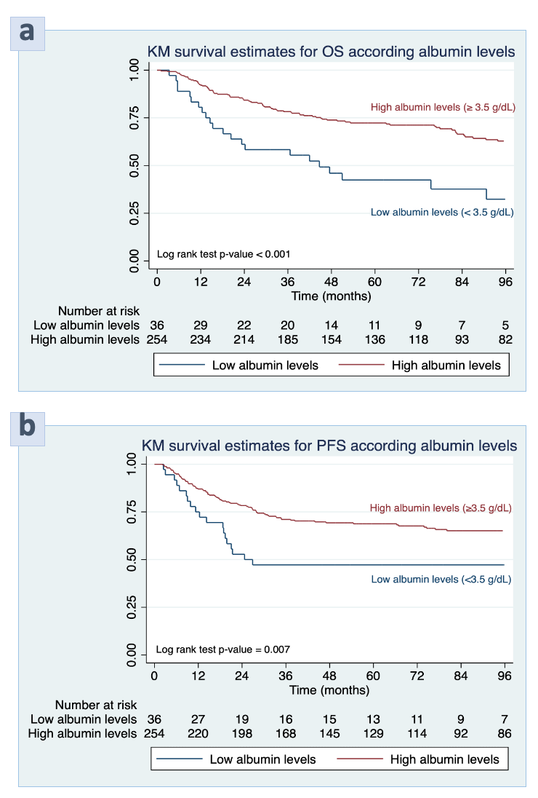

**Suppl. Figure 1.** Kaplan-Meier curves of **a)** overall survival and **b)** progression-free survival of epithelial ovarian clear cell cancer patients stratified by albumin levels